CS160 - W07 – Assignments
Student ID: 25125043
Student Name: Nguyen Quang Hieu

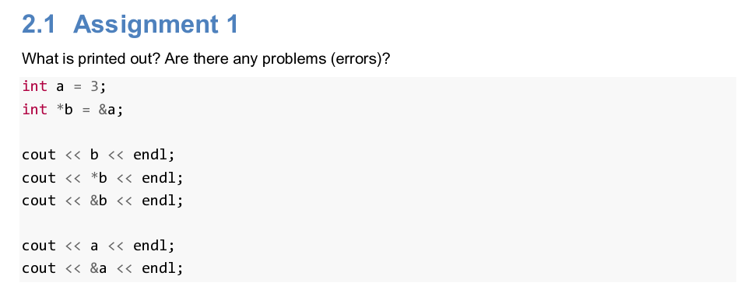
cout << b << endl;
- Address of object b pointing to, which is a
cout << *b << endl;
- Value of object b pointing to, which is value of a
cout << &b << endl;
- Adress of pointer b
cout << a << endl;
- Value of a
cout << &a << endl;
- Address of a
There should be no problems there.

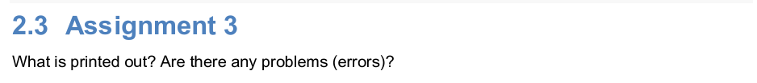
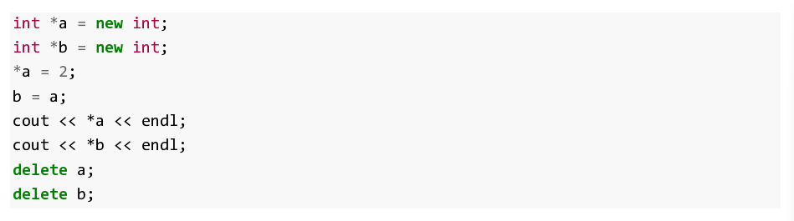
*a = 5;
- Assign a to point to value 5
b = a;
- Assign b to point to the same value as a is pointing to, which is 5
cout << *a << std::endl;
- Print out the value a is pointing to, which is 5
cout << *b << std::endl;
- Print out the value b is pointing to, which is 5
There should be no problems there.

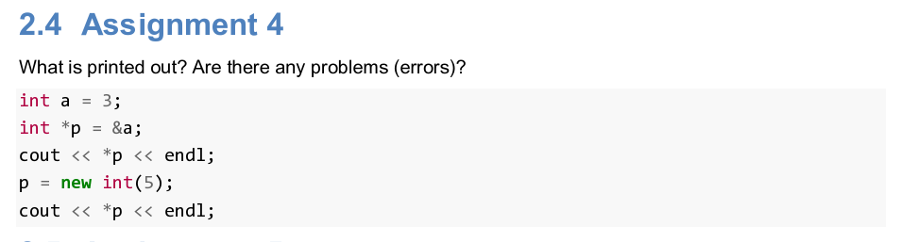
cout << *p << endl;
- Print out the value p is pointing to, which is a or 3
P = new int(5);
- Allocate p to point to value 5
cout << *p << endl;
- Print out the value p is pointing to, which is 5
Problem: Haven’t deallocated p yet.

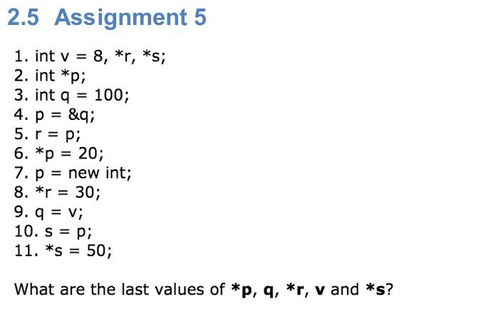
*p: q (100) -> 20 -> new -> 50 (*s = 50)
So *p is 50
q: 100 -> 20 (*p = 20) -> 30 (*r = 30) -> 8 (v)
so q is 8
*r: q (*p) -> 30 -> 8 (q = v)
So *r is 8
v = 8 is unchanged
*s: undefined (*p) -> 50
There should be no problems there.

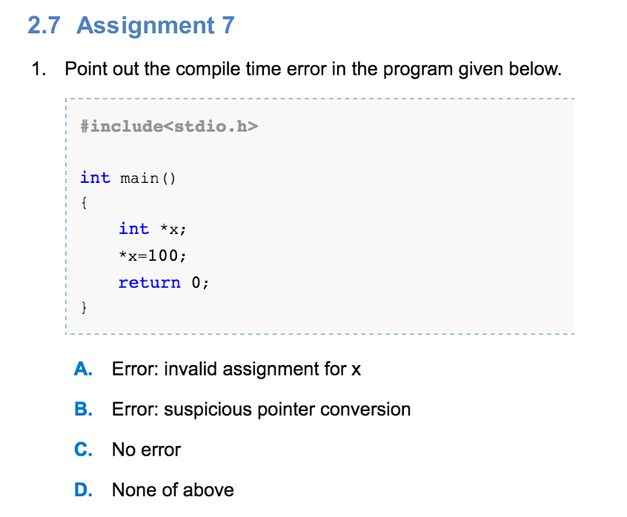
X is a pointer pointing to nowhere, assign 100 to the value x is pointing to would lead to undefined behavior, but it doesn’t cause an error from the 3 issues above.
- D

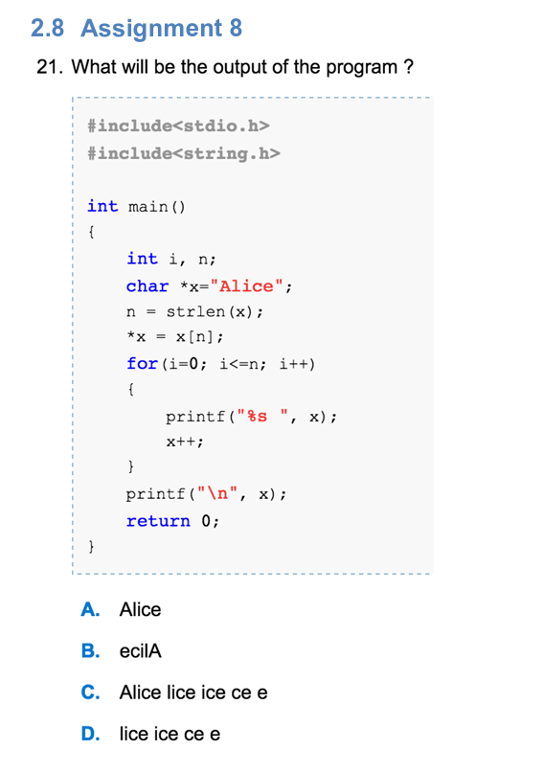
n = 5 (strlen(x) = 5) -> *x = x[5], while x is pointing to x[0] and x[5] = \0 -> x[0] = \0, the string becomes “\0lice\0” -> D

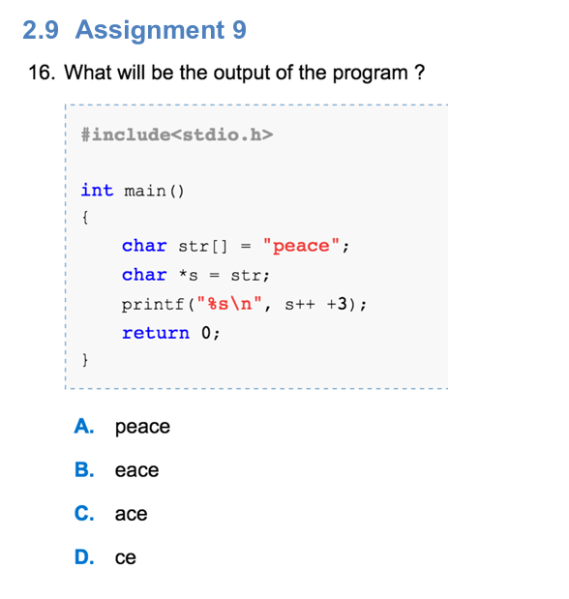
Initially, s points to str[0], which is ‘p’ -> s++ process s first, then increase s to s + 1 -> s++ + 3 process s + 3 first -> print from str[3] onward -> ce

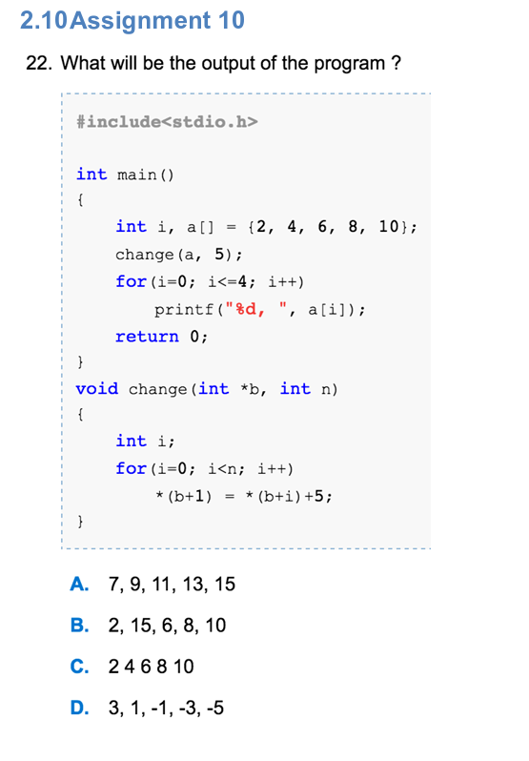
Change(a, 5) change the value at a + 1, which is a[1] to a[i] + 5, so only the last change applies, which means a[1] becomes a[4] + 5 = 10 + 5 = 15 -> B

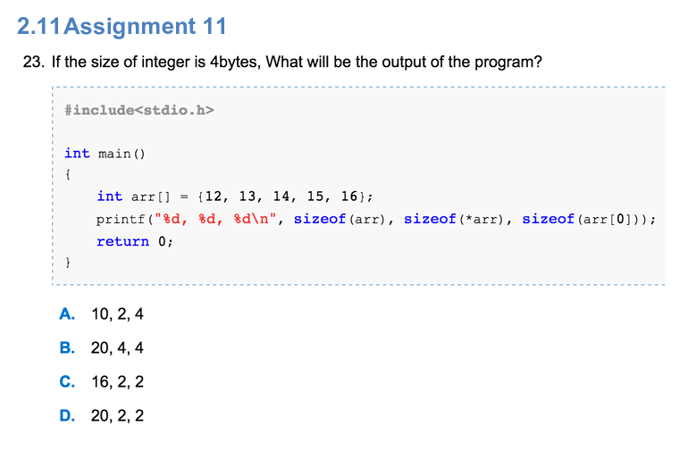
arr consists of 5 integer -> sizeof(arr) = 5*4 = 20
arr points to arr[0] -> deferencing arr leads to arr[0] -> sizeof(*arr) = 4
- B

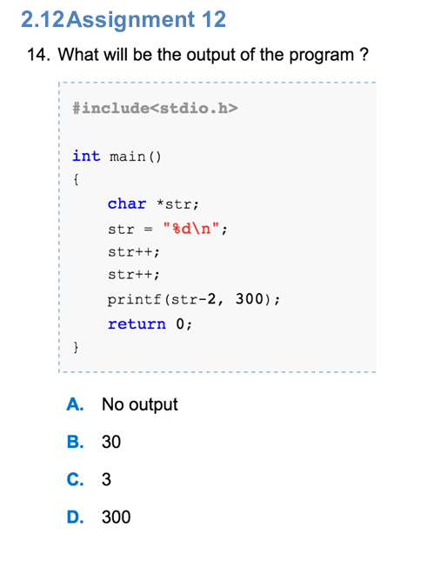
str starts from str[0] -> str++ -> str++ now str starts from str[2] -> str – 2 is “%d\n”
printf(“%d\n”, 300) prints out 300 -> D

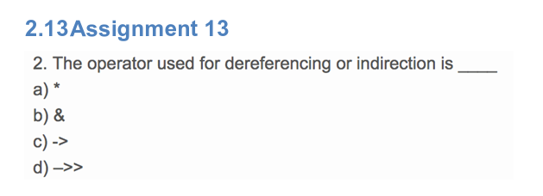
Obviously A

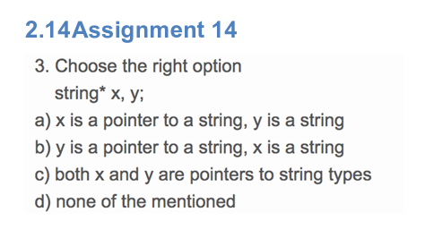
A, for both to be pointers to string, the declaration should be string *x, *y;

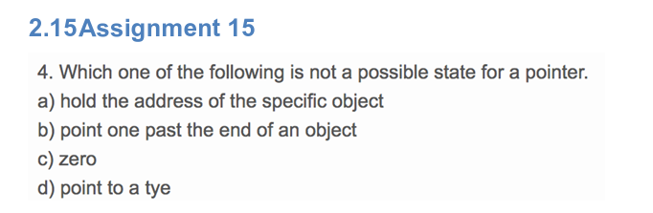
D, a type is not an object or something that can be pointed to

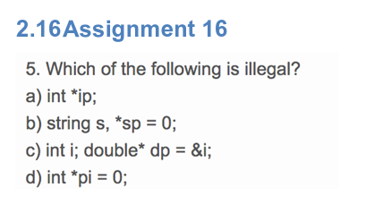
C, because dp must point to an object of double type, otherwise modifying dp will lead to undefined behavior

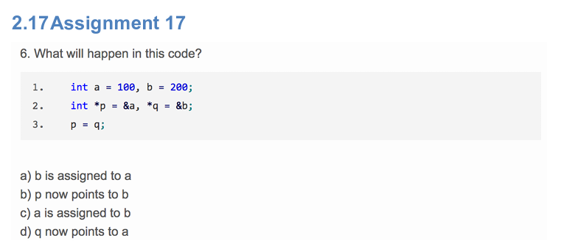
B

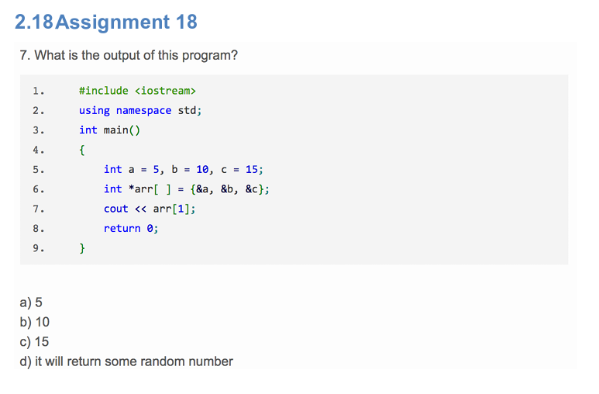
It will print out &b, which is the address of b, which is a random number in this case -> D

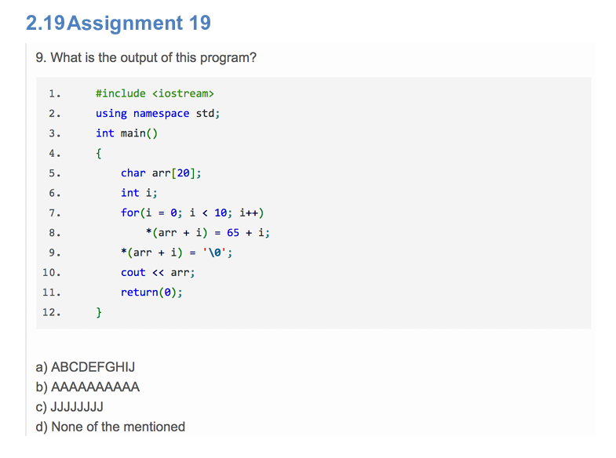
*(arr + i) refers to arr[i], assigning an integer to a char variable will lead to explicit assigning, in this case it will assign from A (65 in binary) to J (74) -> A

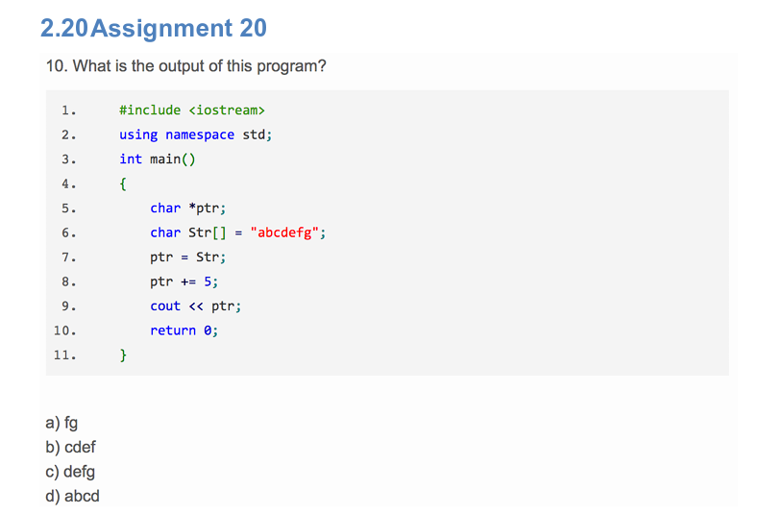
ptr initially points to Str[0] -> ptr + 5 points to Str[5] -> “fg” -> A

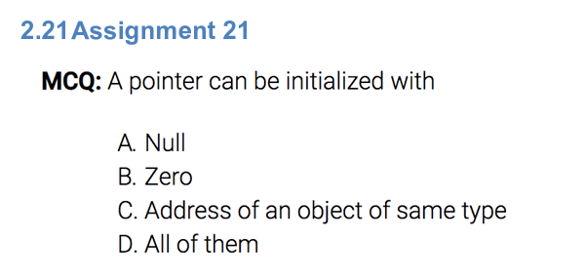
D

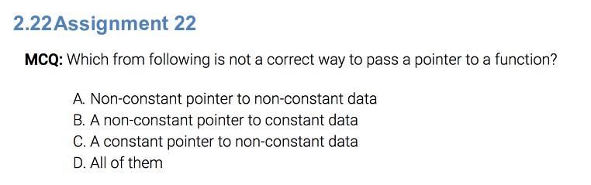
D

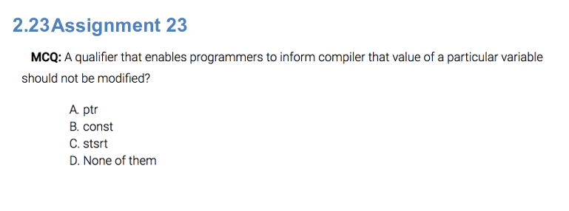
B

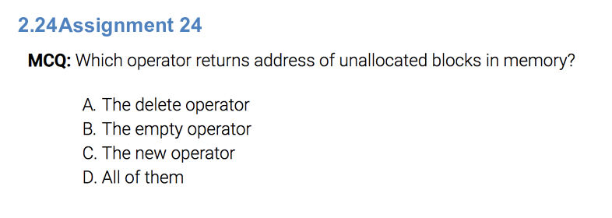
C (unallocated)

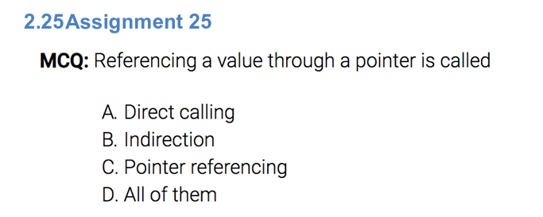
B

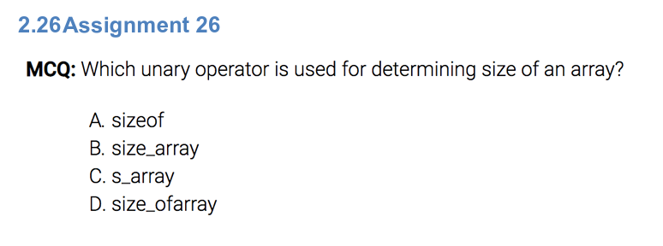
A

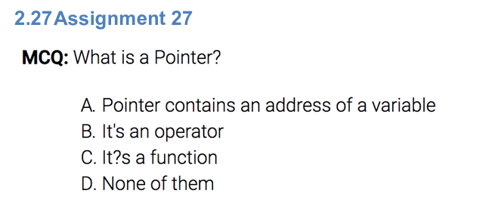
A

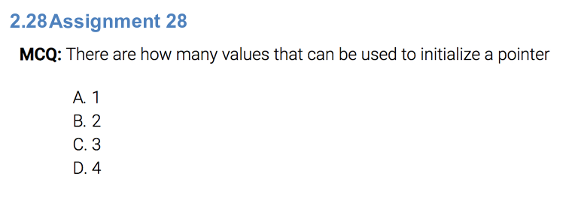
C, address of a variable of the same type, NULL/0 or new block (using new operator)

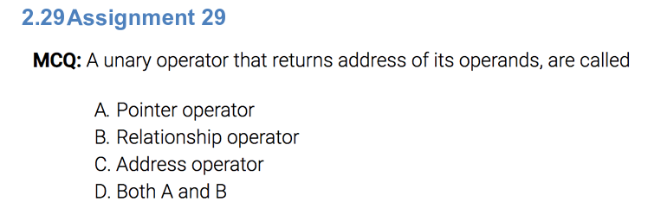
C

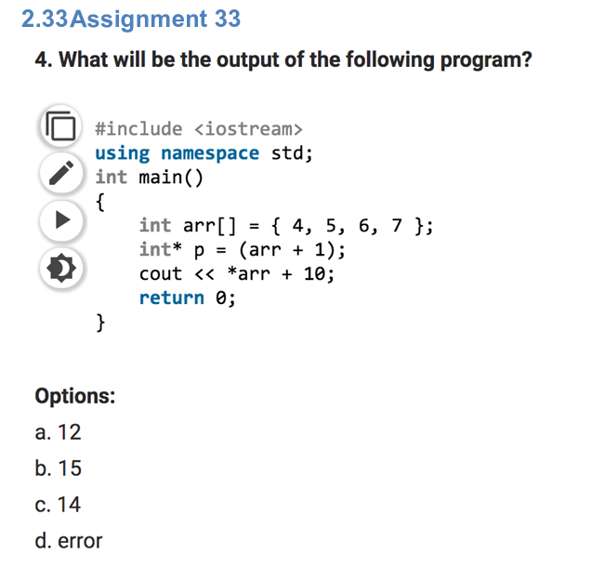
*arr refers to arr[0] -> *arr + 10 = 14 -> C

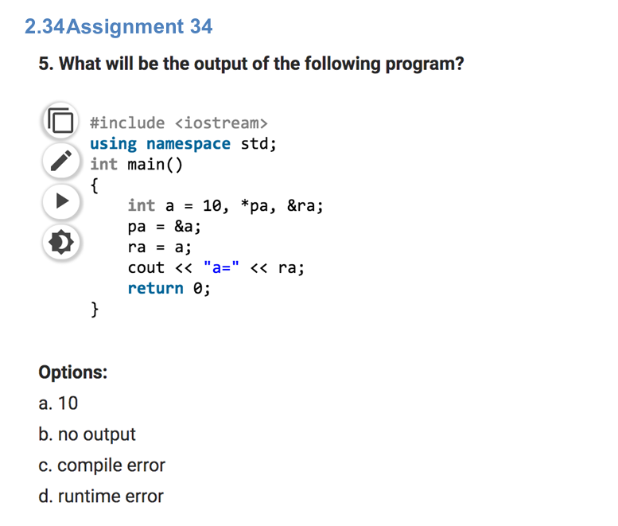
ra hasn’t been declared, so declared &ra is illegal -> C

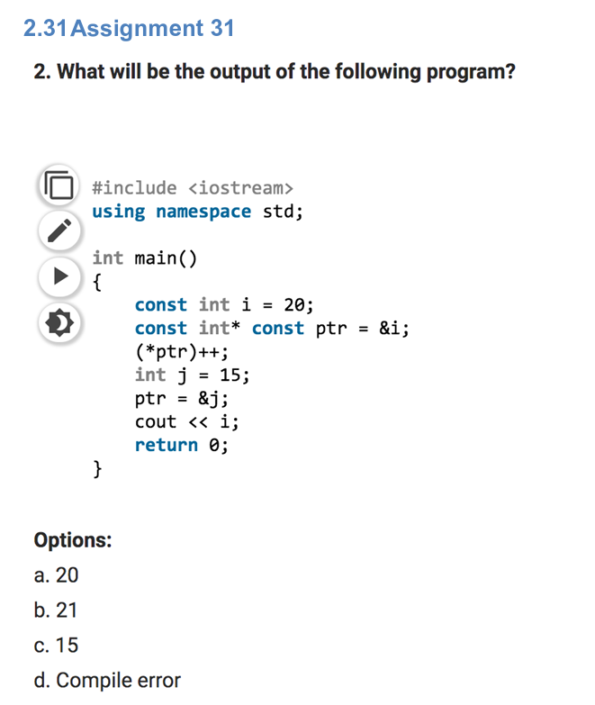
p is a constant pointer points to a constant variable -> can not change p’s direction and what p’s pointing to -> D

